**Project Design Phase-II**

**Data Flow Diagram & User Stories**

|  |  |
| --- | --- |
| Date | 25 june 2025 |
| Team ID | LTVIP2025TMID45798 |
| Project Name | Smart Sorting: Transfer Learning for Identifying Rotten Fruits and Vegetables |
| Maximum Marks | 4 Marks |

**Data Flow Diagrams:**

A Data Flow Diagram (DFD) is a traditional visual representation of the information flows within a system. A neat and clear DFD can depict the right amount of the system requirement graphically. It shows how data enters and leaves the system, what changes the information, and where data is stored.

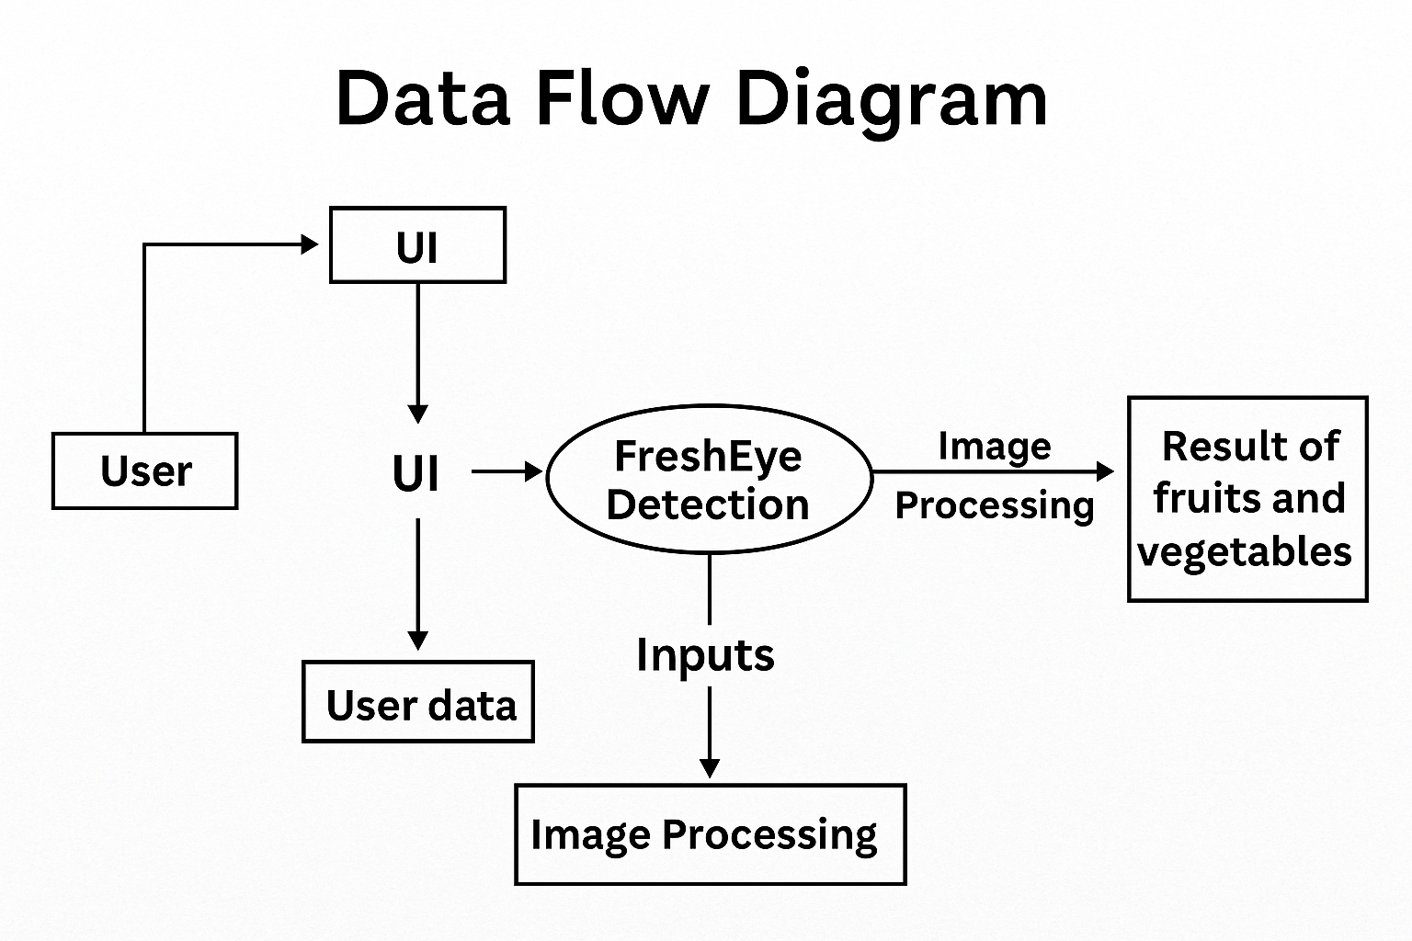

**User Stories**

Use the below template to list all the user stories for the product.

| **User Type** | **Functional Requirement (Epic)** | **User Story Number** | **User Story / Task** | **Acceptance criteria** | **Priority** | **Release** |
| --- | --- | --- | --- | --- | --- | --- |
| Customer (Mobile user) | Upload Image for Prediction | USN-1 | As a user, I can upload an image of fruit/vegetable for freshness detection. | The system accepts and stores the image. | High | Sprint-1 |
|  | View Prediction Results | USN-2 | As a user, I can view whether the uploaded produce is healthy or rotten with the class label shown. | Prediction result displayed on the web page. | High | Sprint-1 |
|  | Download Results (optional) | USN-3 | As a user, I can download or screenshot my prediction result for record keeping. | Option available to save/download results. | Medium | Sprint-2 |
| Admin (System) | Model Management | USN-4 | As an admin, I can update the model with new datasets for improved predictions. | Model updated and tested without downtime | Medium | Sprint-3 |
| Admin (System) | Monitor Performance | USN-5 | As an admin, I can monitor system accuracy and usage statistics. | Dashboard with accuracy metrics available. | Low | Sprint-3 |
| Customer (Web user) | Get Information on Produce | USN-6 | As a user, I can get tips on handling produce after prediction. | Tips shown based on prediction result. | Low | Sprint-3 |